**THIS IS A SUGGESTION ONLY**

For our pitch today we would like to discuss Bill Joy’s controversial article, “Why the Future Doesn’t Need Us” written in the year 2000. Two questions may arise in your head: Who is Bill Joy and what is his article about? 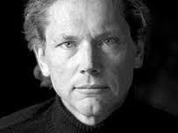

Bill Joy is an American computer scientist, the original author of the ‘vi’ text editor and one of the co-founders of Sun Microsystems, the company that created Java.

Joy’s article proposes a very dystopian view of the future. He has been commonly referred to as “neo-Luddite” although he denies this himself.

Possibly his opinions have surfaced from being around technology for so long and watching it develop as quickly as it has. He worked in Sun Microsystems for around 25 years.

He writes, “Perhaps it is always hard to see the bigger impact while you are in the vortex of a change” 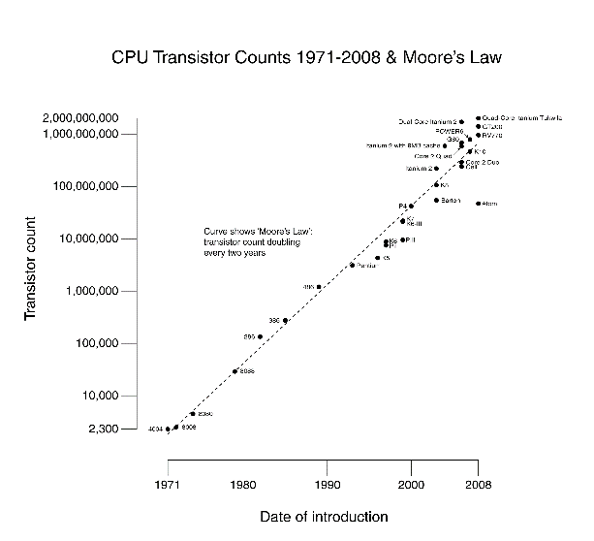

Throughout his article Joy discusses the views of specialists in other scientific fields as well as some unorthodox sources. For example, he quotes Hans Moravec, a leader in robotics research.

He is quite clearly a very credible source to refer to. Moravec himself believed that robots would rapidly displace and replace humans in almost every sector. He also suggested that humans could tax robots to make up for the number of jobs being lost.

This is actually a fairly optimistic viewpoint and one of social determinism, where governments and societies would control the shaping of the future and technology. However, a simple examination of reality tells us the opposite.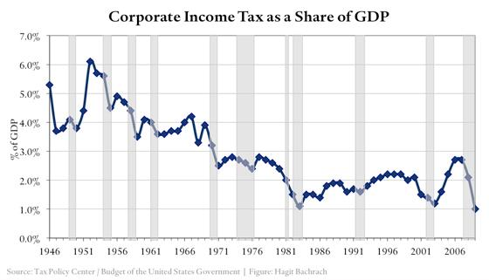

We see an interesting trend in income inequality, where the wealthiest in control are becoming even wealthier than the rest of the population.

The idea that we could simply ‘tax’ the elite once they control all the means of production is simply techno-utopian optimism. It’s an attempt to simply use old solutions to solve new problems. Bill Joy himself didn’t subscribe to these views but instead advised greater caution and deliberation.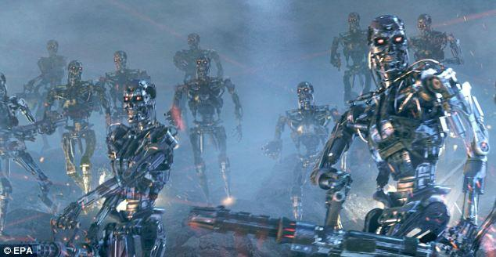

Joy also writes about a meeting with Ray Kurzweil, who suggested in a talk he gave that robotic technologies are actually a lot closer to reality than he once thought.

Kurzweil had a utopian view of our future with technological advances allowing us to fuse with robots and become immortal. However Joy did not agree with Kurzweil’s views.

As an almost counterpoint to this idea of utopian progress of technology, Joy presents an extract from a book of a terrorist called Theodore Kaczynski, also known as the Unabomber.

Kaczynski had a dystopian view on the future where robots would be able to do everything better than humans and thus human effort would become useless. He posed two possible scenarios that could arise . The first where machines are so advanced that they could think and make their own decisions without human oversight. The second scenario is all of the advanced technology would be controlled by a ‘tiny elite’ who would have power over anyone else.

While Joy himself believes that the Unabomber was an extreme Luddite and perhaps a bit too dystopian, he thinks that the Unabomber made an interesting argument. The point that Joy makes that we agree with is that it is necessary to take a broader look at the impact of technology on our world and dangers we may face rather than simply believe in a utopian world.

SHARON:

At the core of this discussion lies a simple point: When we typically first think of a robot, we regard it simply as a machine. We tend to think that it might be operated remotely by a human, or that it may be controlled by a simple computer program. However, this line is increasingly becoming blurred. What if the robot has a biological brain made up of brain cells, possibly even human neurons?

However, the development of AI has become a race between some of the greatest and powerful governments and companies in the world. People are not assessing the risks of this technology rather they are opting for the faster and more convenient option of developing AI. If we fail to foresee the risks of this development, we may indeed suffer the consequences.

If we want to continue improving our machines and devices the development and enhancement of their intelligence is inevitable. Suppose however that we develop a machine with superhuman intelligence. It will be impossible to have full control over that type of device. We may indeed be making a Faustian bargain by giving them the tools, to improve themselves far beyond human comprehension.

*SARAH****:***

What we conclude with is both a viewpoint and a question. The theme of Joy’s article can be described as follows: Just because we can do something, should we do it? The reality is that these rapid technological advancements may instead be throwing fuel to a smoldering flame rather than simply leading us to a perfect utopia. The viewpoint we need to take away from this is that technology is a double-edged sword.

At the same time, we can’t just stop improving technology just because of the fear of the unknown. There’s also a strong deterministic argument to be made that technology will simply drive itself forwards regardless, due to market forces and innovation and that unlike what Moravec and like minded people suggest it’s actually near impossible to control those.

For a final word we suggest you consider Murphy’s law - that is “Anything that can go wrong, will.” 